Using Spring with JPA
Objectives
Key objectives of this chapter:
- Object to Relational Mapping
- Introduction to JPA
- JPA Entities and Key Annotations
- Using Spring with JPA

  - Object to Relational Mapping Frameworks (ORM)
- Object to Relational Mapping (ORM) frameworks automate the low-level database to Java mapping work.
  - Database tables, columns, primary keys, foreign keys, etc. are mapped to Java classes, properties, fields, and collections, etc.
- ORMs provide a higher-level abstraction, developer productivity, reduction of errors, and greater database dialect independence.
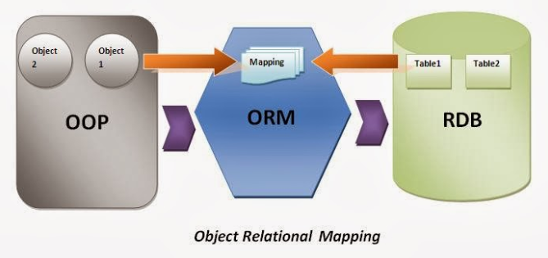
Source: https://interviewquestionjava.blogspot.com/2014/01/framework-orm-object-relational-mapping.html

  - Java ORM frameworks
- Several Java frameworks have addressed ORM:
  - JDO, TopLink, MyBatis, Hibernate

- Java Persistence API (JPA) was established in 2009
  - Established a formal JEE specification for ORM
  - Defines an interface (API) for ORM, not an implementation
  - Heavily influenced by Hibernate and TopLink
  - Implementations include Hibernate, EclipseLink, OpenJPA, Tomee

  - Using JPA in a Spring Application
- To use JPA, a Spring application requires:
  - The JPA JAR (e.g. jakarta.persistence-api.*.jar) on the classpath
  - A JPA implementation (e.g. hibernate-core*.jar) on the classpath
  - Domain classes annotated with mapping metadata (“entities”)
  - An EntityManagerFactoryBean
  - A DataSource (depending on how EntityManagerFactoryBean is obtained).

  - JPA Metadata
- JPA requires mapping metadata to describe how Java objects correspond to underlying database concepts.
- Modern JPA applications use annotations:
// Imports omitted

@Entity // Marks class as persistent entity, mapped to DB table.
@Table("T_CUSTOMER") // Overrides the table name, if not "Customer"
public class Customer {

@Id // Marks the primary key of the table
@GeneratedValue // Tells JPA to provide a unique value on INSERT
private Long id;

@Column(name="NBR") // Column name on table
private String number; // Annotation omitted; column name matches.
private String region;
private Address address; // "Embedded" object
@Transient // Not stored in DB.
private String fullName
//...
}

  - EntityManagerFactoryBean
- Our DAOs will need an EntityManager to work with JPA. These are produced by an EntityManagerFactoryBean.
// Imports omitted

@Configuration
public class Config {

@Bean
public LocalContainerEntityManagerFactoryBean entityManagerFactory(DataSource ds) {
var emfb = new LocalContainerEntityManagerFactoryBean(); // (1)
emfb.setDataSource(ds); // (2)
emfb.setPackagesToScan("com.example.domain"); // (3)

var adapter = new HibernateJpaVendorAdapter(); // (4)
emfb.setJpaVendorAdapter(adapter);

var props = new Properties(); // (5)
props.setProperty("hibernate.show_sql", "true");
props.setProperty("hibernate.format_sql", "true");
props.setProperty("hibernate.use_sql_comments", "true");

emfb.setJpaProperties(props);
return emfb;
}
}
  - Instantiate Spring’s specialized bean for JPA setup.
  - Inject a JDBC DataSource.
  - Which package / sub-packages contain the @Entity classes.
  - Set Hibernate as the JPA implementation.
  - Set various properties, such as how to log SQL statements.

  - Understanding the EntityManager and Persistence Context
- The persistence context is a cache-like environment within which entities are managed, tracked, and synchronized with the database.
- Our DAOs work with EntityManager to manage entities in the Persistence Context.
  - In JPA we do not command the database directly like we do in JDBC.
  - We manipulate entities in memory, then direct the EntityManager to synchronize the persistence context with the database.
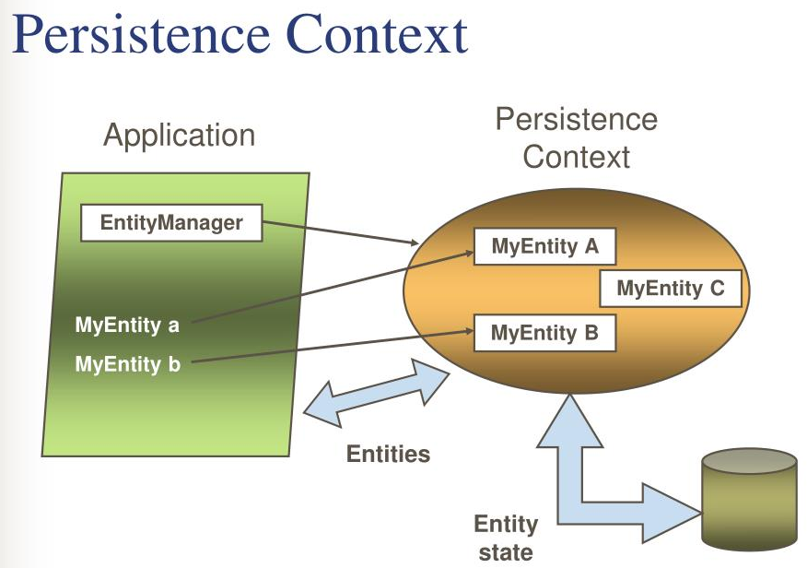
Source: https://image.slideserve.com/845208/persistence-context1-l.jpg

  - Primary EntityManager methods
- The EntityManager has a handful of primary methods for manipulating entities and the persistence context:
Method | Description
persist(Object entity) | Adds a new entity to the persistence context, making it managed and persistent.
merge(Object entity) | Merges the state of a detached entity into the persistence context, updating the corresponding persistent entity.
find(Class<T> entityClass,  Object primaryKey) | Retrieves an entity by its primary key from the database and returns it, or null if not found.
remove(Object entity) | Removes the given entity from the persistence context and database.
createQuery(String qlString,  Class<T> resultClass) | Creates a JPA query object for executing JPQL (Java Persistence Query Language) queries.
flush() | Synchronizes the persistence context with the underlying database, writing changes to the database.
clear() | Clears the persistence context, detaching all managed entities and resetting the EntityManager's state.

  - Entity Lifecycle
- Entities are either “managed” by the persistence context or not.
  - Managed entities are synchronized with the database on flush().
  - JPA handles the UPDATES and DELETES.
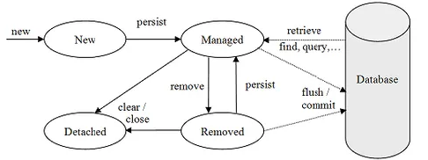
Source: https://velog.io/

  - Spring DAO based on JPA – part 1
- DAO objects can inject the EntityManager and use it.
  - Remember, exception translation is handled automatically in @Repository beans.
// Imports omitted

@Repository // (1)
public class CustomerDaoImpl implements CustomerDao {

@PersistenceContext // (2)
private EntityManager em;

public List<Customer> getCustomers(String city) {
String jpql =
"from Customer as c where c.address.city = :city"; // (3)
return em.createQuery(jpql) // (4)
.setParameter("city", city)
.getResultList(); // (5)
}

// other methods
}

- Use the same @Repository annotation seen in JDBC examples.
- Use @PersistenceContext to inject EntityManager. DO NOT USE @Autowired here!!
- JPA-QL is an object-oriented variant on normal SQL
- Create a query, set the named parameter
- EntityManager will generate SQL, execute on the database, map results into a List of Customers, and store in the persistence context.

  - Spring DAO based on JPA – part 2
// Imports omitted

@Repository
public class CustomerDaoImpl implements CustomerDao {

// other methods

public void save(Customer customer) {
if (customer.getId() == null) {
em.persist(customer); // (1)
} else {
em.merge(customer); // (2)
}
}

// other methods
}

- If this Customer has no primary key, it must be new. Persist() adds it to the persistence context. EntityManager will immediately INSERT to obtain a primary key.
- Merge() checks if an existing counterpart with the same key is in the persistence context. If not, it finds and loads one, then copies property values from the provided object.

  - Why @PersistenceContext, not @Autowired?
- @PersistenceContext is a specialized JPA annotation which only injects EntityManager references.
- Spring injects a proxy EntityManager that:
  - Automatically locates the EntityManager tied to the current transaction.
  - Retrieves one from EntityManagerFactoryBean if none exists.
- Result: code always uses the same EntityManager associated with the current transaction. COMMIT and ROLLBACK work automatically.
- @Autowired would not work; there is no EntityManager bean in the ApplicationContext.

  - Knowledge Check #1
- A co-worker needs help. Spring gives an error when instantiating this bean. The error says there is no bean of type EntityManager. What should be done to fix the code?
@Repository
public class CustomerDaoImpl implements CustomerDao {

@Autowired
private EntityManager em;

// other methods
}

1. Replace @Autowired with @Inject.
2. Replace EntityManager with PersistenceContext.
3. Define a bean of type EntityManager.
4. Replace @Autowired with @PersistenceContext.
5. Replace EntityManager with EntityManagerFactory.

  - Knowledge Check #1
- A co-worker needs help. Spring gives an error when instantiating this bean. The error says there is no bean of type EntityManager. What should be done to fix the code?
@Repository
public class CustomerDaoImpl implements CustomerDao {

@Autowired
private EntityManager em;

// other methods
}

1. Replace @Autowired with @Inject.
2. Replace EntityManager with PersistenceContext.
3. Define a bean of type EntityManager.
4. Replace @Autowired with @PersistenceContext.
5. Replace EntityManager with EntityManagerFactory.

Annotations such as @Autowired, @Inject, and @Resource cannot effectively inject the JPA EntityManager. There is no Bean in the ApplicationContext of type EntityManager, and it would not be thread-safe if there were. Injecting the EntityManagerFactory would result in an EntityManager disassociated from the current transaction.

  - Summary
- ORM frameworks map Java objects to database tables
- JPA is a common API for ORM. Hibernate is a common implementation.
- Domain classes are annotated with JPA annotations to describe mapping metadata
- The EntityManagerFactoryBean is defined as a Spring Bean
- Spring DAOs inject the EntityManager using @PersistenceContext.

